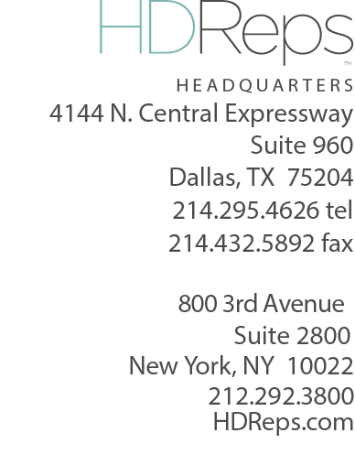
Aaron Streck
National Producer

EXPERIENCE

4/2022 to Present  4/2022 to 1/2018  10/2015 to 6/2017  7/2012 – 7/2015  11/2011 – 6/2012  6/2007 – 11/2011 |  | Global News, Toronto Canada  National Producer/11 pm Toronto  Global News, Durham  MMJ/Anchor  Global News, Edmonton, Alberta  Video Journalist/ENG Camera Operator  Global, Saskatoon  Reporter/Anchor  Global, Edmonton  ENG Camera Operator  Newcap Television,  Video Journalist/Anchor/Producer
EDUCATION
Radio & TV Broadcasting
Western Academy Broadcasting
College (WABC) – 2007



